
Touchstones
Netcards

Authority & Leadership Netcards with Text

Axe HRJ
Boss HRJ
Buddha HRJ
Celebrate HRJ

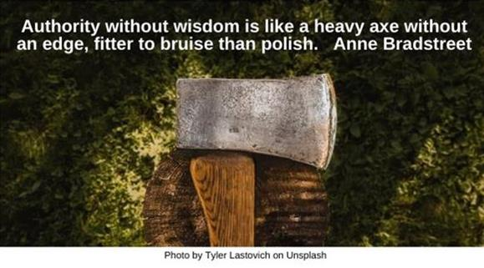

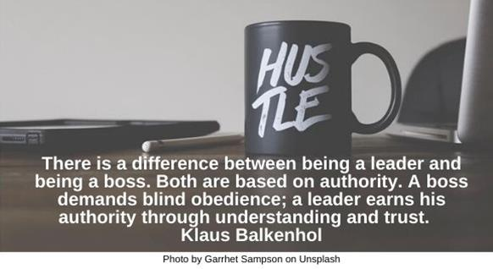



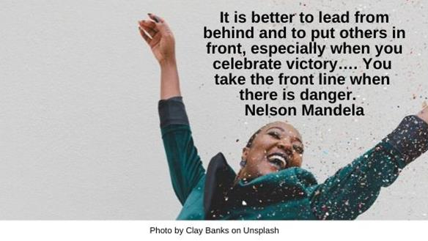
Comfort Zone HRJ
Darkness HRJ
Dawn HRJ
Desert HRJ

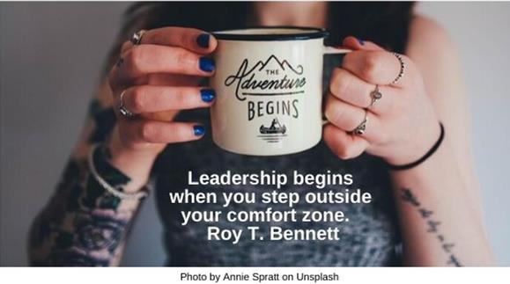

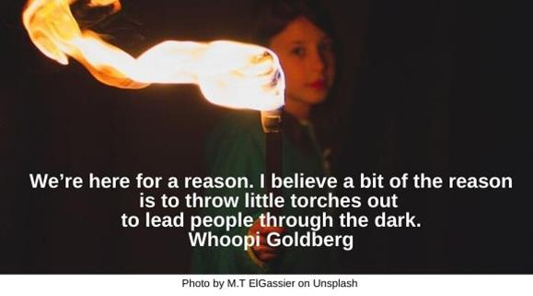

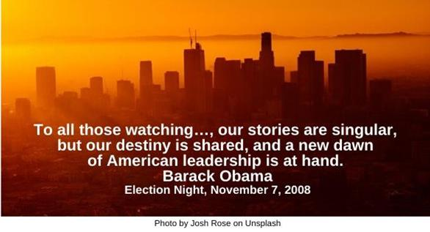

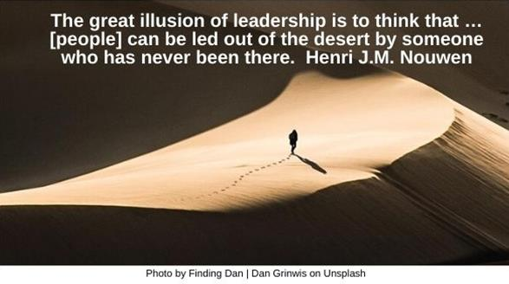
Dream HRJ
Einstein HRJ
Flag HRJ
Galileo

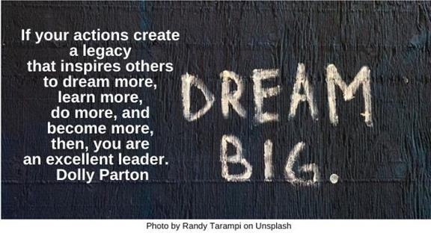

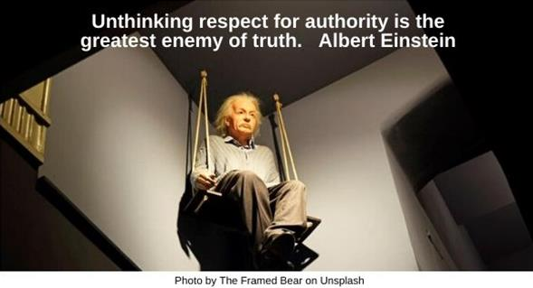

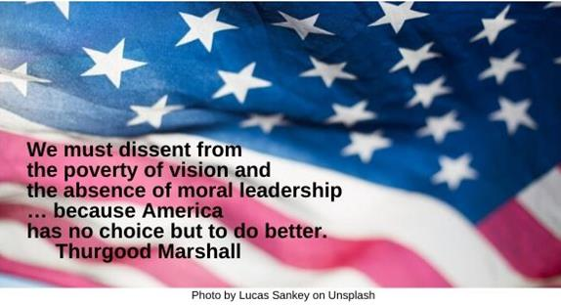

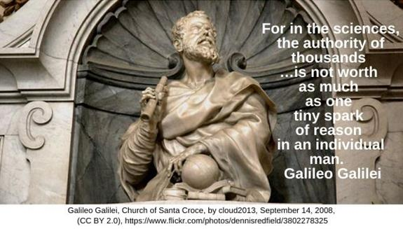

Gandhi HRJ
Ideas HRJ
Ignore Authority HRJ
Imagination HRJ

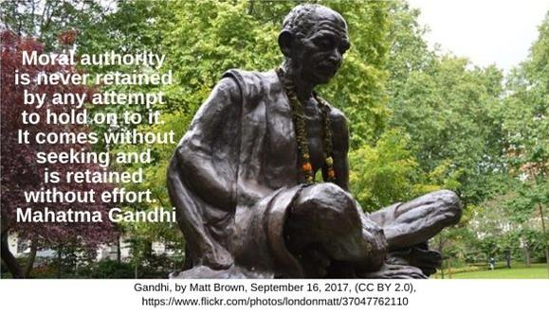



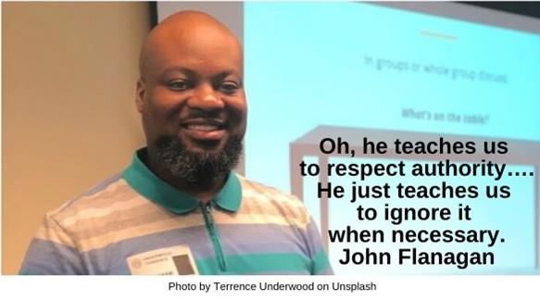


Jazz HRJ
Ladder HRJ
Line HRJ
Love HRJ

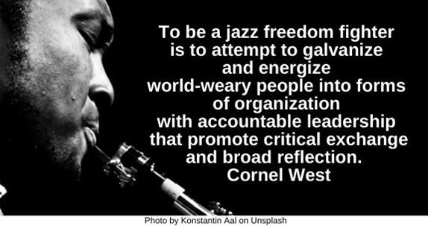

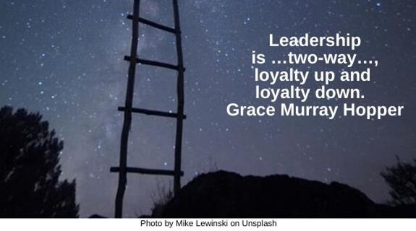

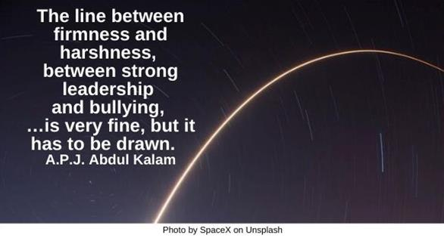

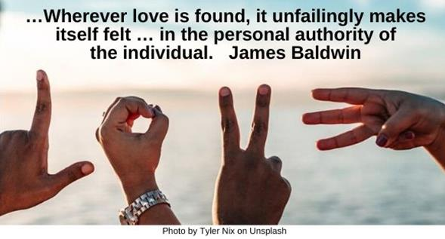

Mature HRJ
Mentor HRJ
Mount Rushmore HRJ
Pope HRJ



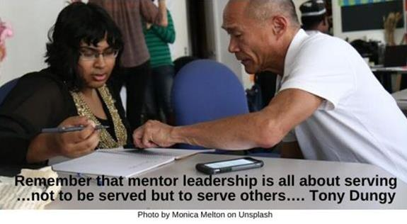

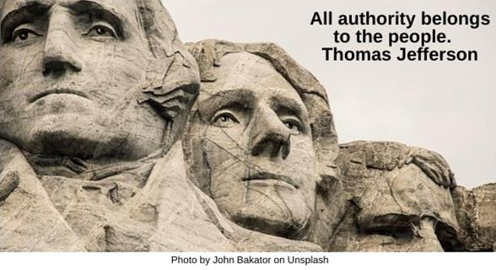

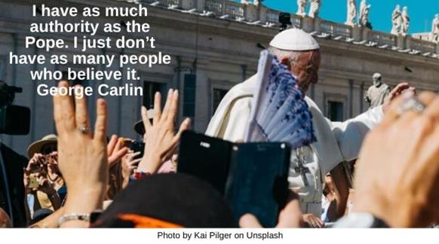

Responsibility HRJ
Shepherd HRJ
Truth HRJ
Two Routes HRJ

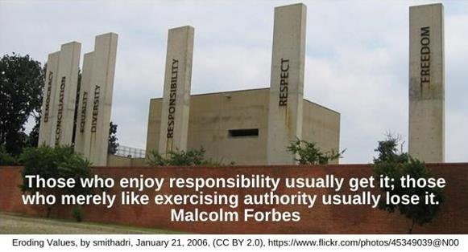

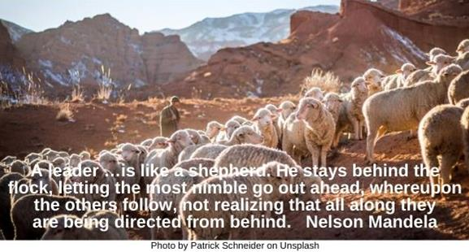

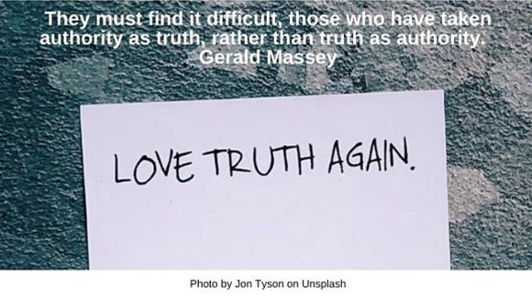

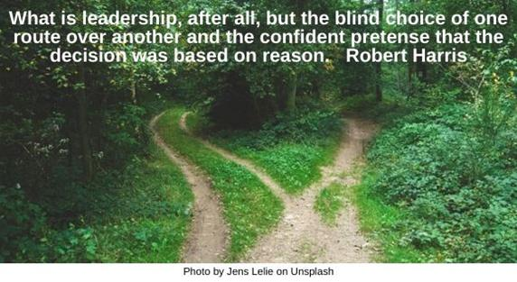

Universe HRJ
Wise HRJ
Wrong Way HRJ

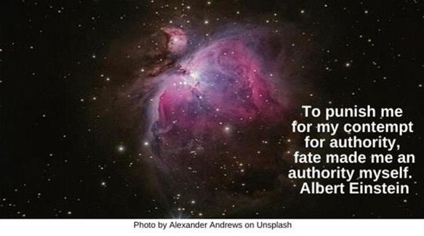

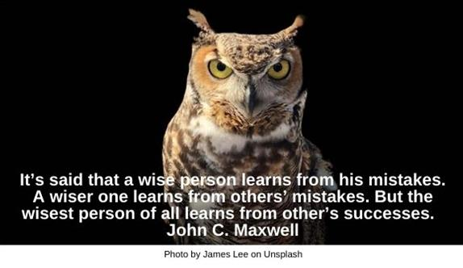

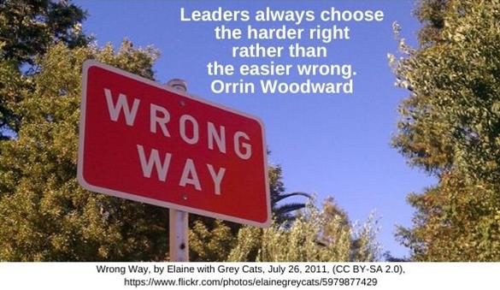

Success HRJ
The Poor HRJ
Too Late HRJ

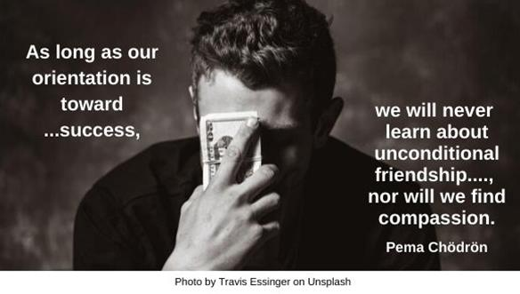

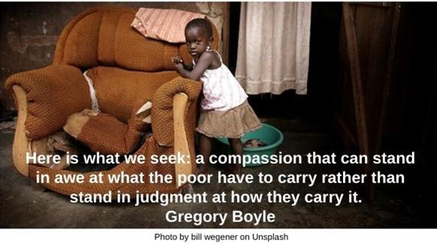

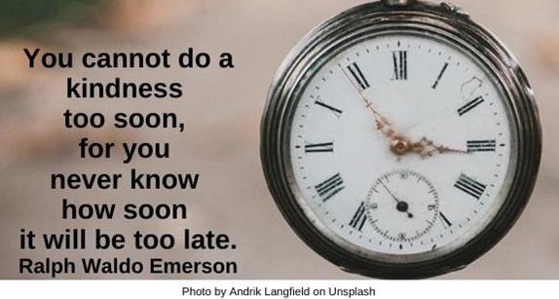

Understanding HR
Unseeing HRJ
Verb HRJ
Yourself HRJ

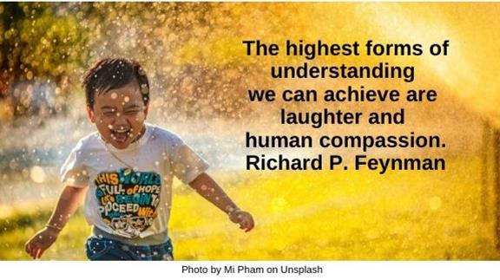

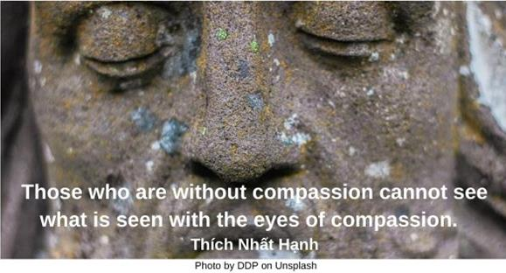



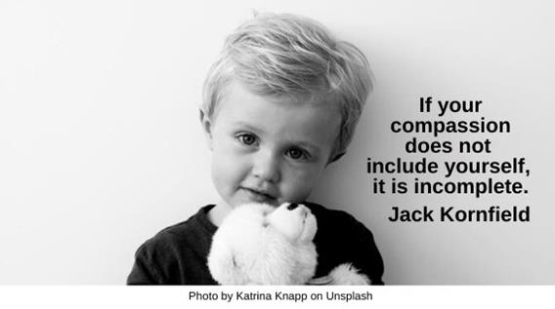

Text of Quotes
Axe
Authority without wisdom is like a heavy axe without an edge, fitter to bruise than polish. Anne Bradstreet

Boss
There is a difference between being a leader and being a boss. Both are based on authority. A boss demands blind obedience; a leader earns his authority through understanding and trust. Klaus Balkenhol

Buddha
Do not believe in anything merely on the authority of your teachers and elders. Buddha

Celebrate
It is better to lead from behind and to put others in front, especially when you celebrate victory…. You take the front line when there is danger. Nelson Mandela

Comfort Zone
Leadership begins when you step outside your comfort zone. Roy T. Bennett

Darkness
We’re here for a reason. I believe a bit of the reason is to throw little torches out to lead people through the dark. Whoopi Goldberg

Dawn
To all those watching tonight from …, our stories are singular, but our destiny is shared, and a new dawn of American leadership is at hand. Barack Obama, Election Night, November 7, 2008

Desert
The great illusion of leadership is to think that …[people] can be led out of the desert by someone who has never been there. Henri J.M. Nouwen

Dream
If your actions create a legacy that inspires others to dream more, learn more, do more and become more, then, you are an excellent leader. Dolly Parton

Einstein
Unthinking respect for authority is the greatest enemy of truth. Albert Einstein

Flag
We must dissent from the poverty of vision and the absence of moral leadership … because America has no choice but to do better. Thurgood Marshall

Galileo
For in the sciences, the authority of thousands …is not worth as much as one tiny spark of reason in an individual man.

Gandhi
Moral authority is never retained by any attempt to hold on to it. It comes without seeking and is retained without effort. Mahatma Gandhi

Ideas
Leadership is the art of giving people a platform for spreading ideas that work. Seth Godin

Ignore Authority
Oh, he teaches us to respect authority…. He just teaches us to ignore it when necessary. John Flanagan

Imagination
Authority is itself inherently an act of imagination. Richard Sennett

Jazz
To be a jazz freedom fighter is to attempt to galvanize and energize world-weary people into forms of organization with accountable leadership that promote critical exchange and broad reflection. Cornel West

Ladder
Leadership is …two-way…, loyalty up and loyalty down. Grace Murray Hopper

Line
The line between firmness and harshness, between strong leadership and bullying, …is very fine, but it has to be drawn. A.P.J. Abdul Kalam

Love
…Wherever love is found, it unfailingly makes itself felt … in the personal authority of the individual. James Baldwin

Mature
You become mature when you become the authority of your own life. Joseph Campbell

Mentor
Remember that mentor leadership is all about serving …not to be served but to serve others…. Tony Dungy

Mount Rushmore
All authority belongs to the people. Thomas Jefferson

Pope
I have as much authority as the Pope. I just don’t have as many people who believe it. George Carlin

Responsibility
Those who enjoy responsibility usually get it; those who merely like exercising authority usually lose it. Malcolm Forbes

Shepherd
A leader …is like a shepherd. He stays behind the flock, letting the most nimble go out ahead, whereupon the others follow, not realizing that all along they are being directed from behind. Nelson Mandela

Truth
They must find it difficult, those who have taken authority as truth, rather than truth as authority. Gerald Massey

Two Routes
What is leadership, after all, but the blind choice of one route over another and the confident pretense that the decision was based on reason. Robert Harris

Universe
To punish me for my contempt for authority, fate made me an authority myself. Albert Einstein

Wise
It’s said that a wise person learns from his mistakes. A wiser one learns from others’ mistakes. But the wisest person of all learns from other’s successes. John C. Maxwell

Wrong Way
Leaders always choose the harder right rather than the easier wrong. Orrin Woodward

